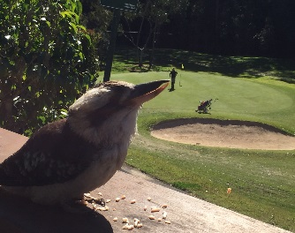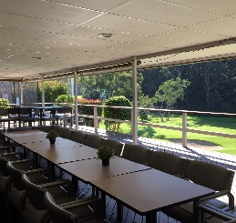 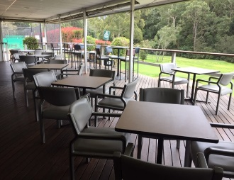
Tee 4 Two BBQ Café
_____________________________________
MENU
Grilled Salmon on a bed of Mash Potato with Salad $15.00

4 Sliders (Beef, Cheese, Pickle & Lettuce) $12.00
Fish & Chips with Salad $14.00
Cheeseburger with Chips $14.00

Beef Pie with Chips $10.00

Spinach Quiche with Salad $12.00
Ham, Cheese & Tomato Toasted Sandwich $ 6.00
Bowl of Chips $ 5.00

Coffee $ 4.00
___________________________________

